FIRST LUTHERAN CHURCH
A D.O. J.O.Y. Congregation

Pastor – Rev. John T. Conrad Sunday School 9:15am Sunday Worship 8am & 10:30am

HOLY COMMUNION
ELW (Red) Hymnal.

WELCOME!
GATHERING

CONFESSION and FORGIVENESS p.116-118
GATHERING SONG “Christ Is Alive! Let Christians Sing” 389
GREETING & KYRIE p.120-121
CANTICLE OF PRAISE “This is the Feast…” p.122-123
PRAYER OF THE DAY Front of Celebrate

WORD

FIRST READING Acts 16:9-15 Celebrate
RESPONSIVE READING OF Psalm 67 Celebrate
(Sing Response)
SECOND READING Revelation 21:10, 22----22:5 Celebrate
GOOD NEWS FOR CHILDREN (All children may come to the front, those that wish to go to the Little Lutheran Room may do so after the story)
GOSPEL ACCLAMATION
“Alleluia, alleluia…!” p.124
GOSPEL READING John 14:23-29 Celebrate

SERMON Pastor John

HYMN OF THE DAY “I Want to Walk as a Child of the Light” 815
NICENE CREED p.126
PRAYERS OF INTERCESSION Back of Celebrate
PEACE p. 128

THANKSGIVING

OFFERING “Special Music”
OFFERTORY PRAYER p.129

GREAT THANKSGIVING p.129-130
INVITATION TO COMMUNION p.134
LORD’S PRAYER p.134
COMMUNION SONG “Lamb of God…” p.135
COMMUNION DISTRIBUTION SONG
“Let Us Break Together” 471
AFTER COMMUNION SONG “Now, Lord…” p.135
PRAYER p.136

SENDING

ANNOUNCEMENTS
BLESSING p.136
SENDING SONG “Go, My Children, with My Blessing” 543
DISMISSAL p.137

t t t t t t t t t t t t t t t t t t t t t t t t t t t t t t t t t t t t t t
WELCOME to this sacred time of praising and praying together;
of singing, speaking and listening together;
of being strengthened together in faith, for service. Amen.

t t t t t t t t t t t t t t t t t t t t t t t t t t t t t t t t t t t t t t
All baptized guests and members are welcome
to partake in communion today.
All children who have not had First Communion instruction
from the church are welcome to come up for a blessing.

t t t t t t t t t t t t t t t t t t t t t t t t t t t t t t t t t t t t t t
To all members & guests,
please fill out an attendance card and
drop it in the offering plate or leave with an usher.

t t t t t t t t t t t t t t t t t t t t t t t t t t t t t t t t t t t t t t
Guests, we look forward to seeing you again.

May 01, 2016 Sixth Sunday of Easter

WORSHIP LEADERS & ASSISTANTS

PASTOR Rev. John T. Conrad

MINISTERS The People of First Lutheran

MUSIC Manahara Virasinha

USHERS E Britt Benson, Pat Caisse, Joyce Yosko,
Team 1 Milton & Jeanette Blackburn, Janis Schroeder
L Russell & Margie Boening,
Charlie & Ginny Glowka,
Paul & Nancy Traeger, Sherman Posey

READERS E Dorothy Stolle
L Jim Helmke

SOUND E Alan Schmidtberger
TECH L Doug Bielefeld

ACOLYTES E Alex Jarutowicz & Sean Sanders
L Blye Mangum & Rance Mangum

GREETERS E Amanda Gorzell & Shelly Gorzell
L Kim Pruski & Judy Rhew

COMMUNION E B – Danny Curtis
W – Ellen Conrad & Annette Kunkel
L B – Marvin Bielefeld
W – Ginny Glowka & Melissa Mangum

ALTAR In loving memory of, Mary Ann Zunker’s birthday -
FLOWERS 5/10/1933, given by, Michelle & Tom Gay & family

TELLERS Polly Archer & Liz Scheitle

ALTAR Lolly Lange, Laura Lange,
GUILD Lisa Baumann, Shirley Polasek

SHEPHERDING E Carolyn Orth
TEAM L Melinda & Darrell Cokely

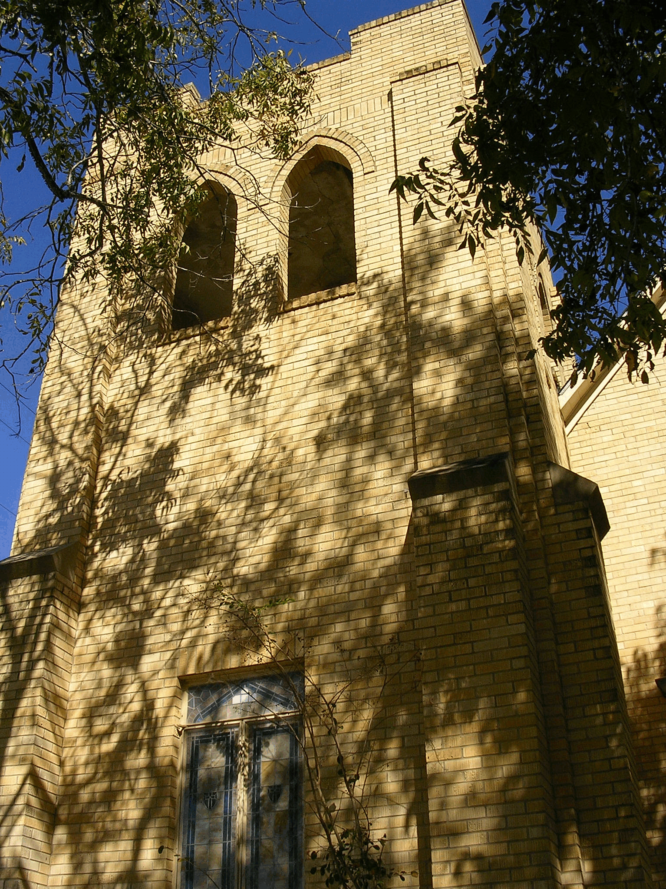

First Evangelical Lutheran Church - NALC
1406 6th St., Floresville, Texas 78101 830-393-2747
Website: floresvillelutheran.org

